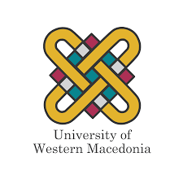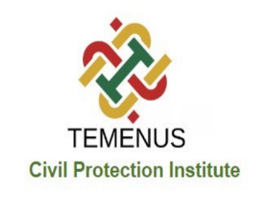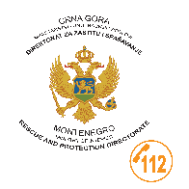
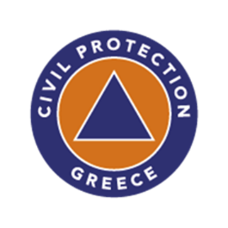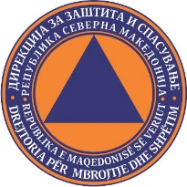

In September, a partner’s meeting took place in Korca, Albania, as part of the ROSES - Cross Border Risk Awareness in Western Balkans project.
The ROSES project aims to develop an approach of co-creation and co-design, focusing on risk awareness and communication, as well as educational activities targeting the public, volunteers, first responders, and civil protection services.
The project is led by the Laboratory of Technology Management (MaterLab), in collaboration with the Institute of Civil Protection.
Participating in the project are the European University of Cyprus, the Ministries of Interior of Montenegro and Bosnia-Herzegovina, the Center for Development and Democracy of Albania, the National Office of Civil Protection of Albania, the Directorate for Protection and Rescue of North Macedonia, the General Secretariat of Civil Protection of Greece, and the Geographical Information Studies, Services, and Software Company of Greece.
The meeting was coordinated by the University of Western Macedonia through MaterLab, the Institute of Civil Protection, and Professor I. Bakouro.
ROSES aims to increase and strengthen awareness of risks, exchange best practices, and raise risk awareness through actions to support host countries in cross-border areas.
ROSES also aims to increase awareness of risks and exchange best practices, focusing on supporting cross-border areas. Its goal is to enhance collaboration among different partners and improve protection and response to hazards and emergency situations. Through actions such as risk awareness, communication, and education, the ROSES project seeks to enhance the response capabilities of volunteers, first responders, and civil protection services.
During the meeting, the objectives and activities implemented in the previous months of the ROSES project were presented, and discussions were held regarding its future and direction.

